# **Design Patterns**

1. **Creational patterns**provide object creation mechanisms that increase flexibility and reuse of existing code.
2. **Structural patterns**explain how to assemble objects and classes into larger structures, while keeping these structures flexible and efficient.
3. **Behavioral patterns**take care of effective communication and the assignment of responsibilities between objects.
4. **Class patterns** deal with relationships between classes and their subclasses. These relationships are established through inheritance, so they are static—fixed at compile-time.

**Object patterns** deal with object relationships, which can be changed at run-time and are more dynamic

# **Inheritance versus Composition**

* The two most common techniques for reusing functionality in object-oriented systems are **class inheritance** and **object composition.**
* **Class Inheritence** lets you define the implementation of one class in terms of another’s.
* Reuse by subclassing is often referred to as **white-box reuse**.
* The term "white-box" refers to **visibility**: With inheritance, the internals of parent classes are often visible to subclasses.
* **Object composition** is an alternative to class inheritance.
* New functionality is obtained by assembling or *composing* objects to get more complex functionality.
* Object composition requires that the objects being composed have well-defined interfaces.
* This style of reuse is called **black-box reuse**, because no internal details of objects are visible. Objects appear only as "black boxes."

# **Class inheritance**

**Advantages**

* Supported by programming languages, defined statically at compile-time and is straightforward to use.
* Make it easier to modify the implementation being reused, when a subclass overrides some but not all operations.

**Disadvantages**

* Cannot change the implementations/representations inherited from parent classes at run-time.
* Implementation dependency between a subclass and its parent class.

# **Object composition**

**Advantages**

* Defined dynamically at run-time by referencing interfaces of objects.
* Access other objects though their interfaces only, do not break encapsulation.
* Fewer implementation dependencies.
* Small class hierarchies

**Disadvantages**

* Design based on object composition have more objects
* The system's behavior will depend on their interrelationships instead of being defined in one class

**One of the principle of object-oriented design: Favor object composition over class inheritance.**

# **How to select a Design Pattern?**

* Consider how design patterns solve design problems.
* Scan Intent sections.
* Study how patterns interrelate.
* Study patterns of like purpose.
* Examine a cause of redesign.
* Consider what should be variable in your design.

**Factory Method**

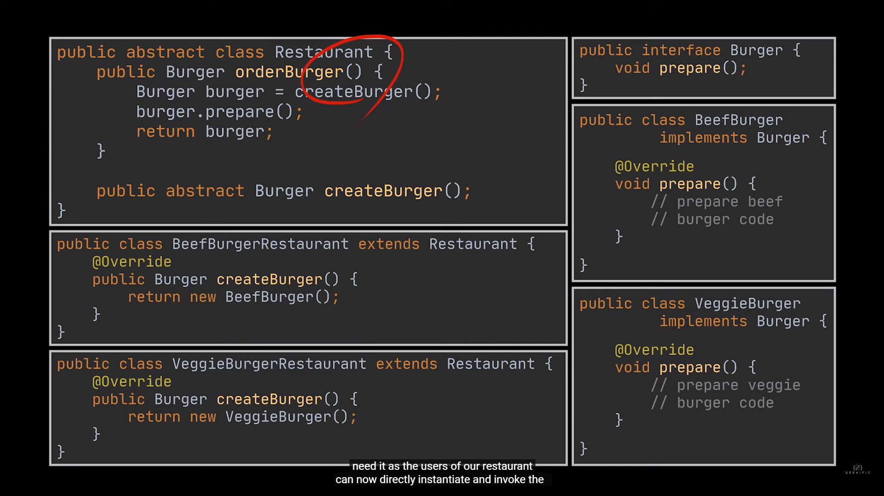

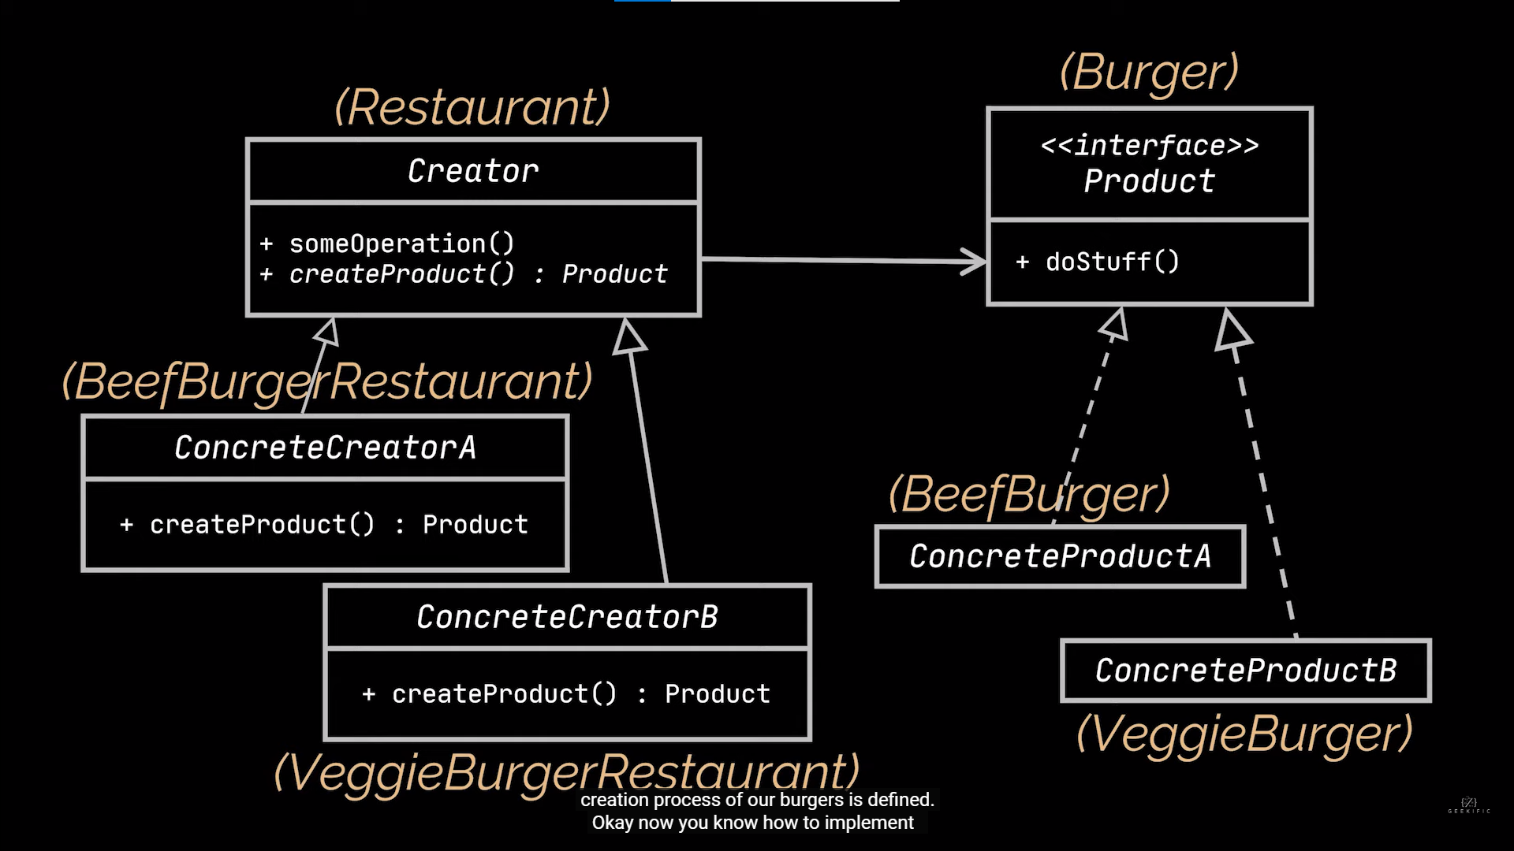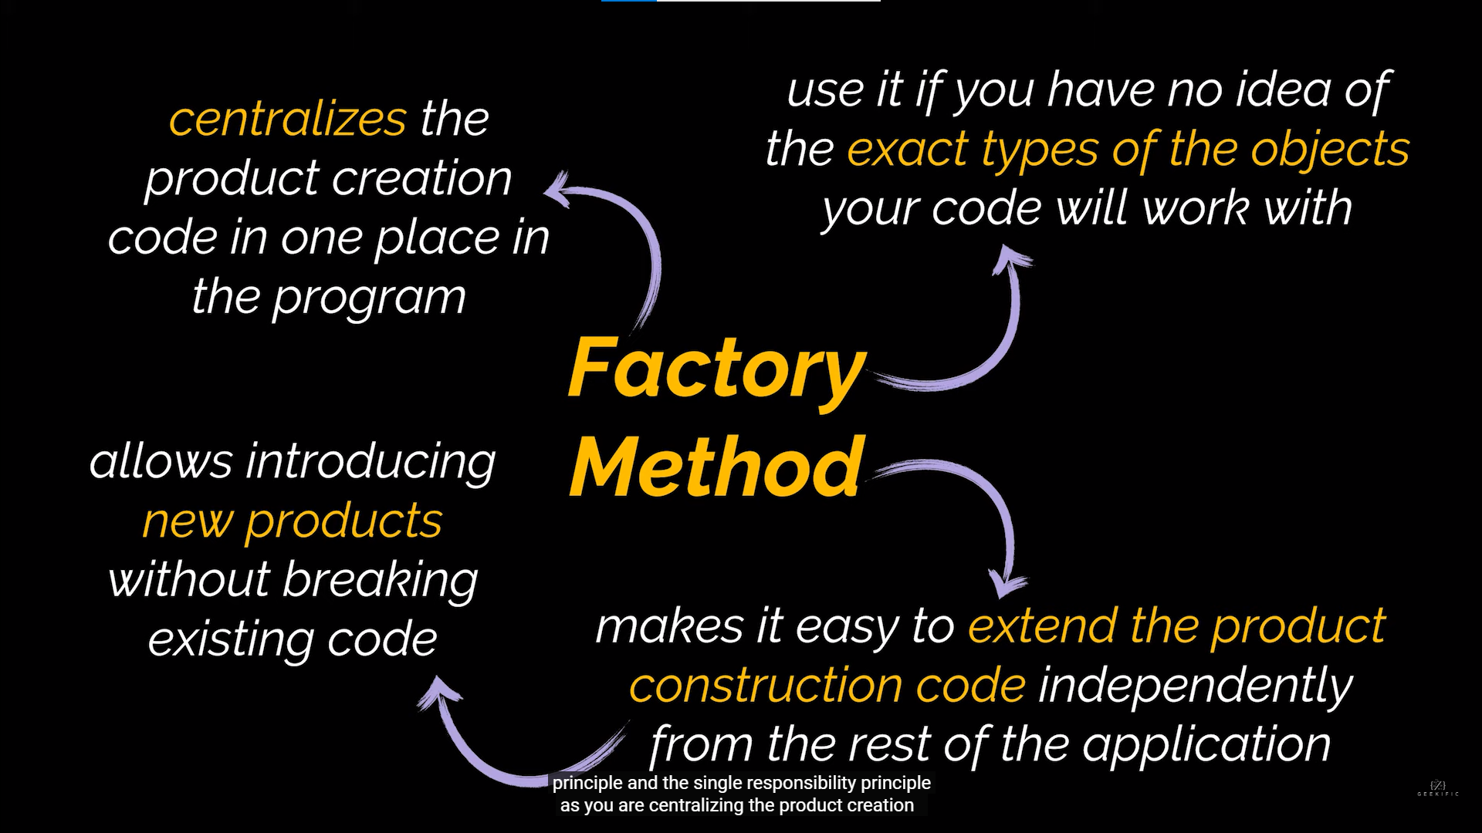

**Singleton Method**

